



**BSLMC Application for Administrative**

**Review of Research**

**Submitter/PI Instructions**

Version 4.0

Office of Clinical Research

**Table of Contents**

**Definitions** 3

**Logging into BSLMC Administrative Application** 4

**Basic Layout and Navigation** 5

**Search** **Study** 7

**Start New Device Form** 7

**Start New Pricing Form** 10

**Start New Application** 11

**PI Attestation, Acknowledgement and Submission** 20

**Institutional Approval or Deferral** 22

**Institutional Acknowledgement for Expanded Access** 24

# **Definitions**

Enterprise Computing Account (ECA) – Access to the application requires a BCM ECA. This is also known as your Baylor email username. If you do not have an ECA, please contact the IT Service Center at 713-798-8737 or be <https://it.bcm.edu/>.

Submitter – Person that completes the investigational device assessment form and/or application for BSLMC administrative approval for submission to the PI. This can be a regulatory person, administrative person, coordinator, or anyone working on the study with knowledge about the research study.

Principal Investigator (PI) – The person(s) in charge of a clinical trial or a scientific research grant. The principal investigator prepares and carries out the clinical trial protocol (plan for the study) or research paid for by the grant. The principal investigator also analyzes the data and reports the results of the trial or grant research. The principal investigator will receive the new application submission from their submitter for review and submission to the review team.

Review Team – Review team or Administrative Review Team is the staff in the Office of Clinical Research that will review application for completeness and seek all necessary approvals from Baylor St. Luke’s Medical Center. Review team will be the primary contacts for the submitter and PI for any questions during the review.

Institutional Approval – BSLMC administrative approval from institutional official over research. Final approval before study can start at BSLMC.

Expanded Access – The use of an investigational drug, biologic or device outside of a clinical trial for treatment of a patient. Compassionate Use (also called Individual Patient/Small Group Access) and Emergency Use are two mechanisms of expanded access.

# **Logging into BSLMC Administrative Application**

Log in using your username and password. If you do not have a Baylor ECA, you can submit a request from BCM IT service portal (<https://it.bcm.edu>) by entering a ticket.

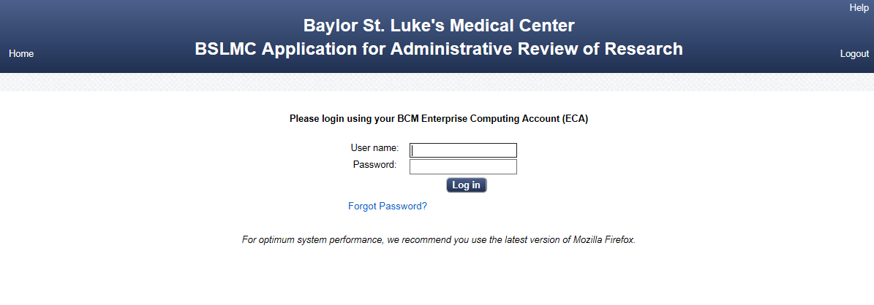

Select Application being submitted (Device, Pricing Request, Full Application or Amendment) in the Welcome Screen:

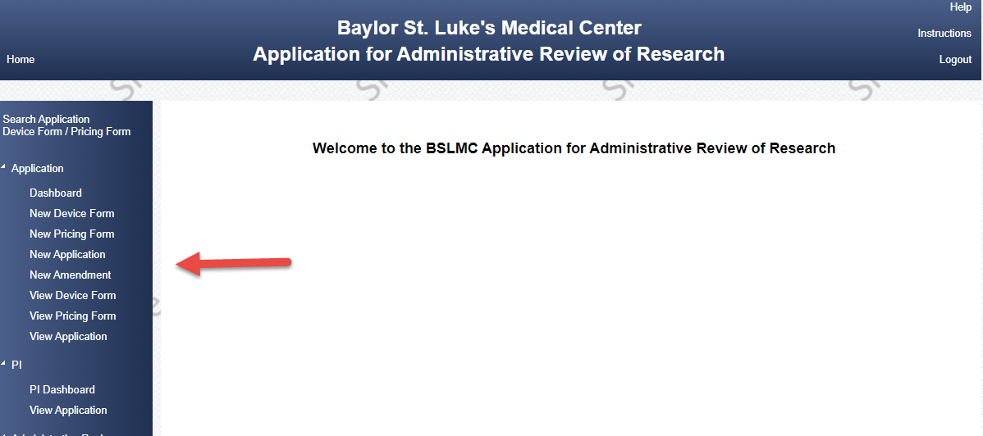

For technical issues, please contact [Office of Research IT](mailto:researchit@bcm.edu).

# **Basic Layout and Navigation**

Home – takes you to the Welcome Screen.

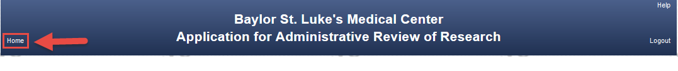

Help – pop-up screen with contact information.



Logout – logs out of system, user name and password are required to re-enter system.



Instructions – opens the Submitter Guide

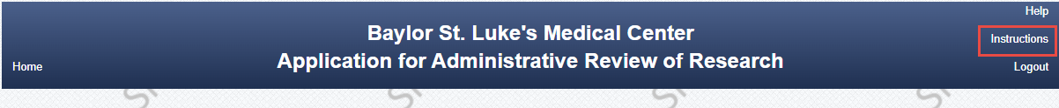

Menu – allows access to new device form, pricing request form, new application, amendment to an approved application, or enables you to see device form or application previously created/submitted.

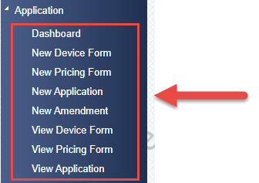

Do not use the browser’s back button. Use the menus in the system to navigate the different sections of the module.

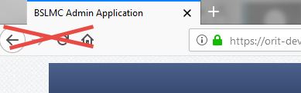

Most pages that include fields for data entry require clicking on an “Edit” button  (towards the bottom of the page) to begin. Once in edit mode, clicking on the “Save” button  locks in the information or to exit without saving, click the “Cancel” button.

Some tables within a page include a scrolling option in order to view additional information. Click on the scroll bar next to the table to move it up or down, left or right.

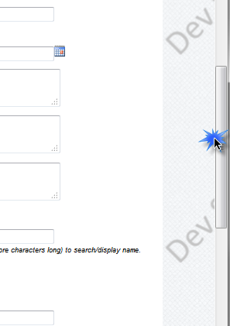

# **Search** **Study**

Once logged into the system, you can use the Application Menu to find a previous drafted application or open a PDF of a previously submitted Device Form, Pricing Form or Application.

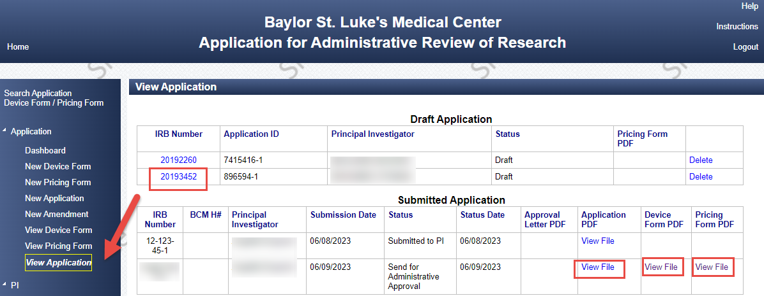

# **Start New Device Form**

Select New Device Form from the Menu. Enter the PI’s name. If the PI does not have an ECA, check the box and the PI will receive an email with instructions for ECA login. Enter IRB#, if available. This will facilitate linking to full application if submitted at a future date.

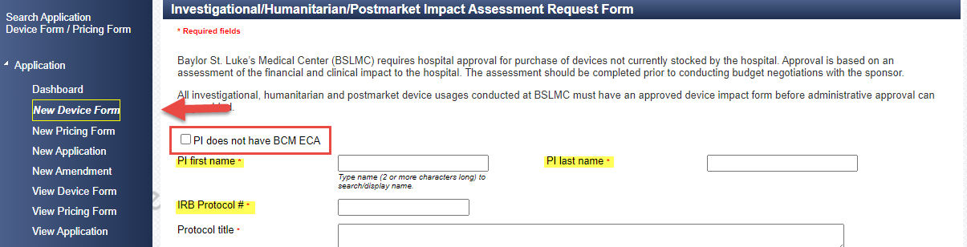

Complete all required**\*** fields, Save and click Next to complete next page.

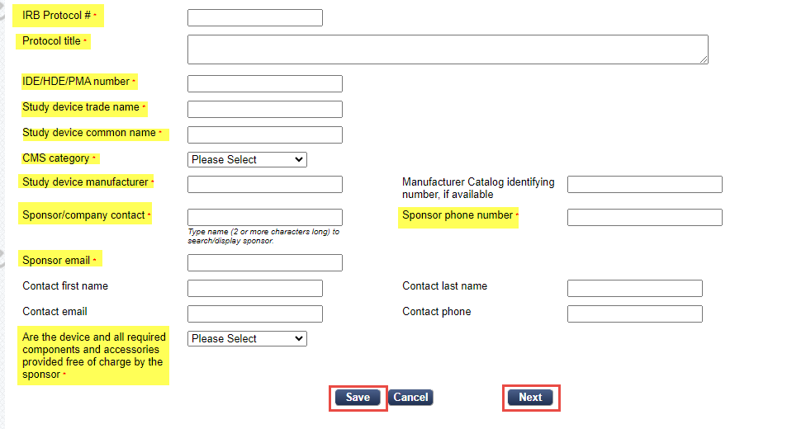

Complete all required**\*** fields, Save and click Submit. You can go back to the Menu to view your submitted device form and open and save the PDF.

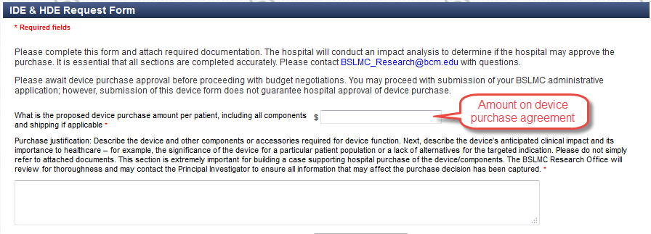

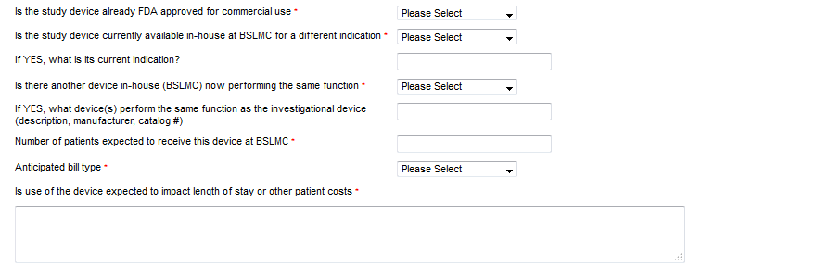

Attach required documents:

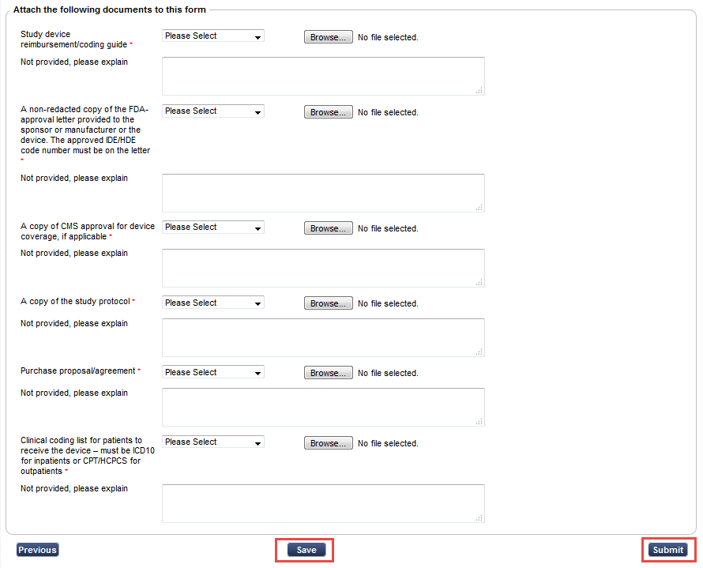

# **Start New Pricing Form**

Select New Pricing Form from the Menu. Enter IRB#, if available. If IRB# is not available yet, enter a study short name or something relevant to facilitate linking to full application if submitted at a future date. Enter the PI’s name. If the PI does not have an ECA, check the box and the PI will receive an email with instructions for ECA login. Complete all fields of the application, attach protocol, schedule of events and consent form if available. Include CPT code for all tests/procedures that pricing is requested and whether it will be done in-patient and/or out-patient. ICD 10 procedure codes may be needed for in-patient procedures. Provide any comments that may help with developing the fee schedule, i.e. alternate codes that may be utilized

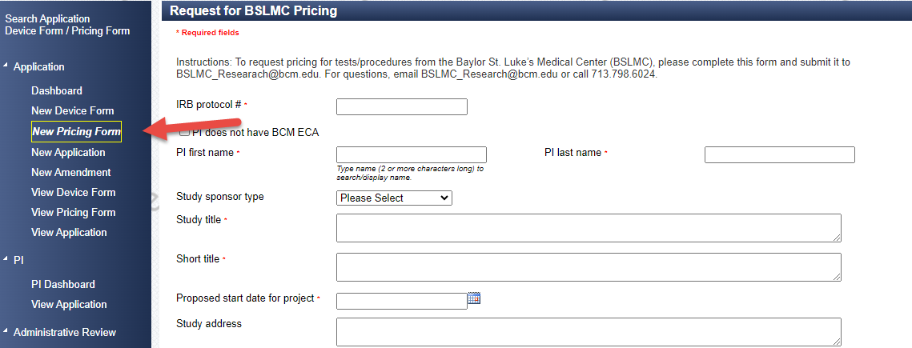

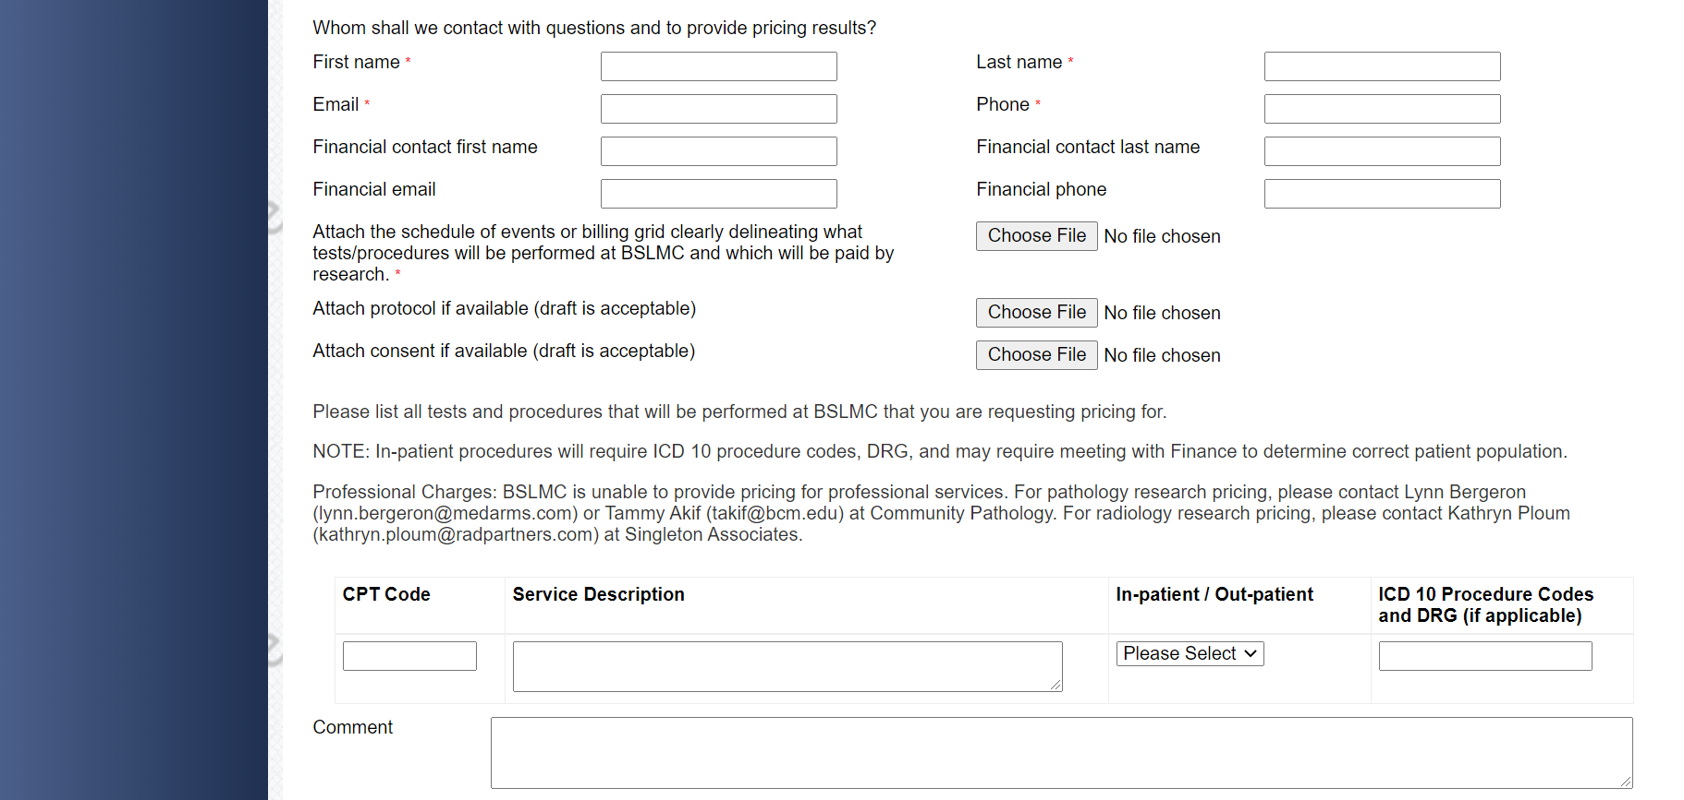

# **Start New Application**

Select New Application from the Menu.

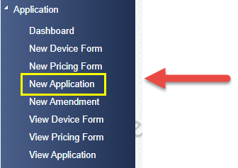

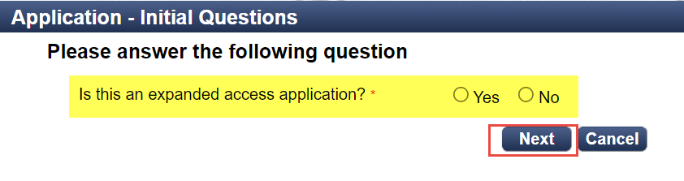

If the answer is Yes to Expanded Access, then you will complete an abbreviated application for institutional acknowledgement of the use of test article. Abbreviated application has some of the same fields as full application below, but requires specifics about the test article, copy of protocol, consent form and IRB approval letter. Submit and we get notified that an application is ready for us to review.

**NOTE: Expanded Access application is only for compassionate use or emergency use of a test article.**

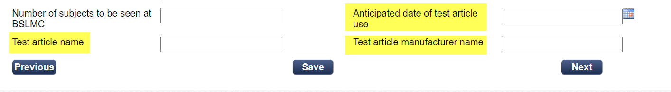

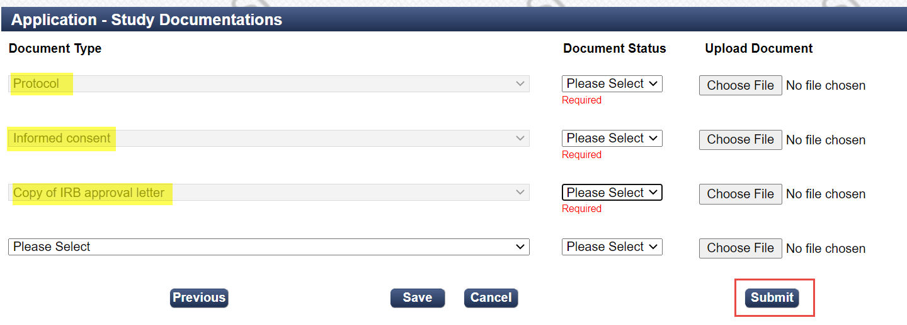

If the answer is No to Expanded Access, then you will answer the following questions regarding if this is a device study or if research pricing is needed.

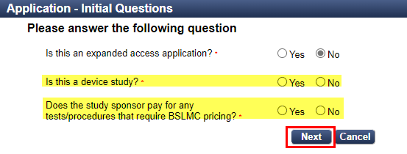

If either of those are Yes, then you will need to complete the form or attach a previously submitted form to move forward. Click Next and new application for administrative review for BSLMC approval will open.

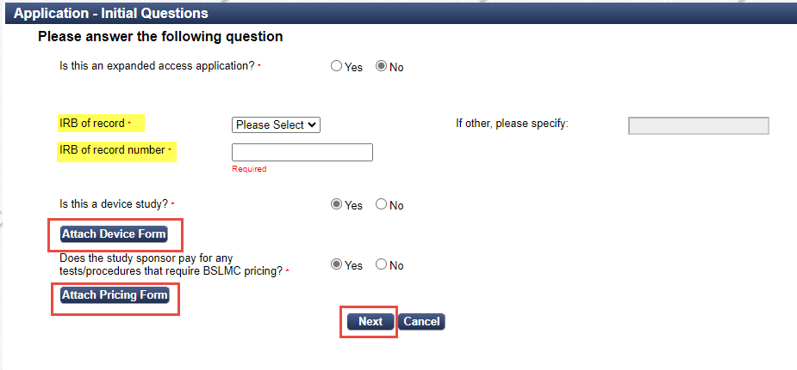

Complete all required**\*** fields of new application:

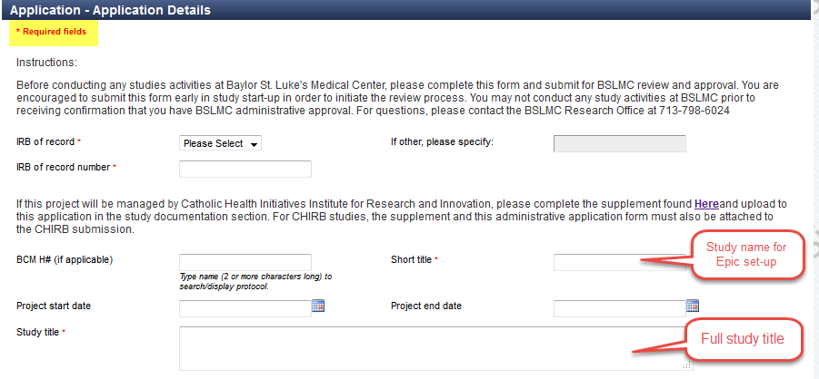

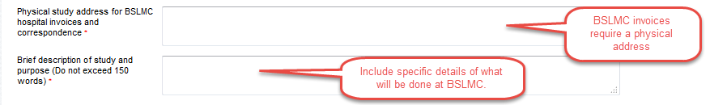

Enter the PI’s name and contact information. If the PI does not have an ECA, check the box and the PI will receive an email with instructions for ECA login. *PI is required to submit the application upon completion by Submitter.*

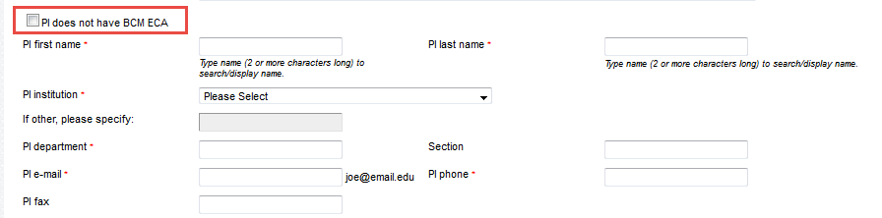

Enter primary and/or administrative contact’s name and contact information. If the financial contact is the same, check the box.

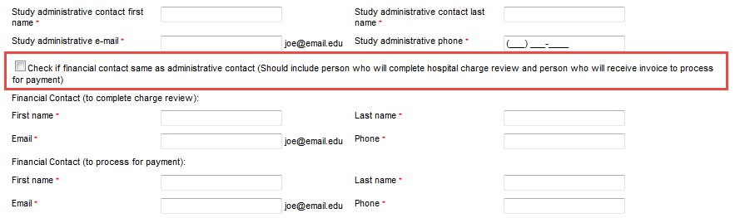

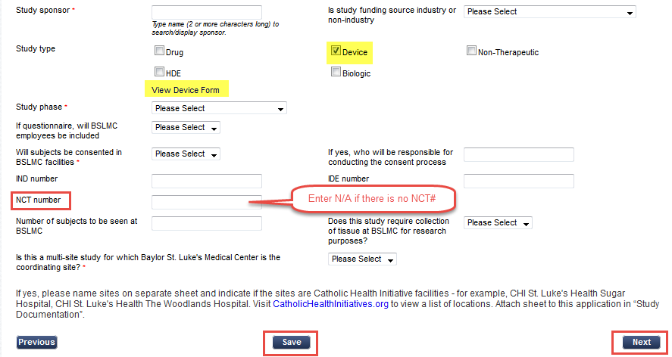

Save and click Next to complete next page.

Enter all study personnel that will have access to BSLMC patients and/or their protected health information (PHI). Please select if personnel has BSLMC Epic access and whether they will review hospital charges. If personnel needs Epic access for their study duties, please contact [BSLMC_research@bcm.edu](mailto:BSLMC_research@bcm.edu) for information on research credentialing to get Epic access.

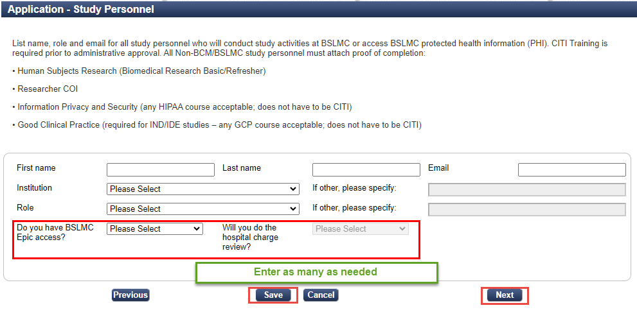

Check boxes for all department areas and regulatory committees that apply to this study.

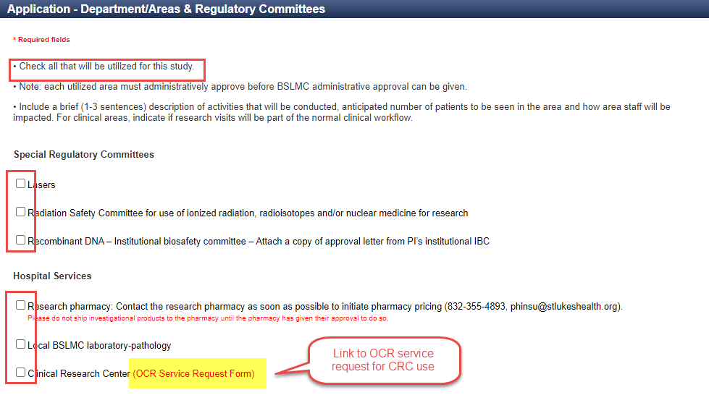

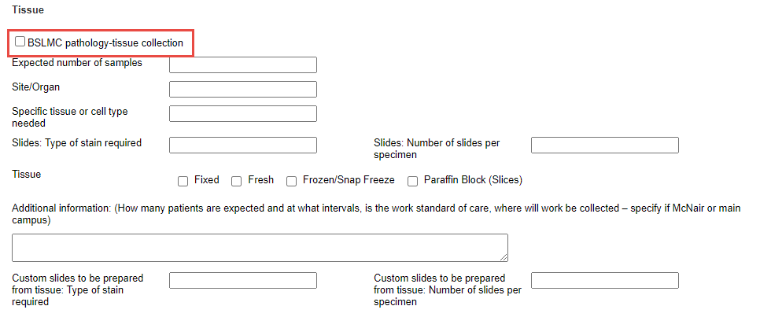

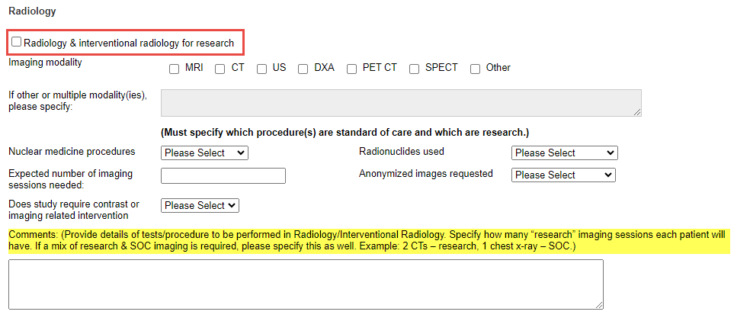

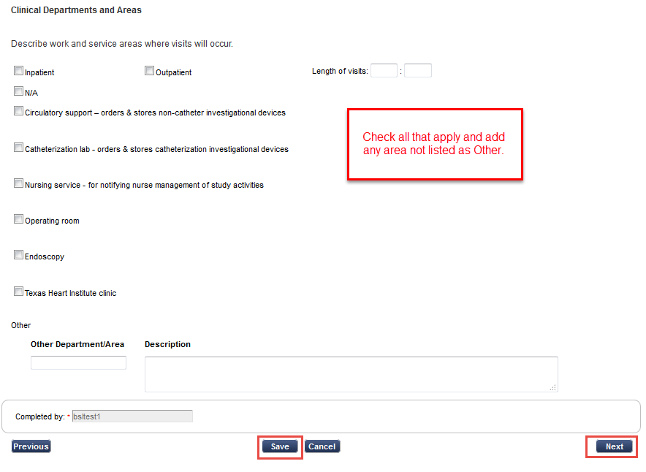

Add study documents for review. Each instance of document status must be completed to be able to Submit the application. Additional documents, not listed or if there are multiple (i.e., central IRB & reliance IRB approval letters, etc.) may be added. CITI training certificates are only required if done for an institute other than BCM, BSLMC, or THI.

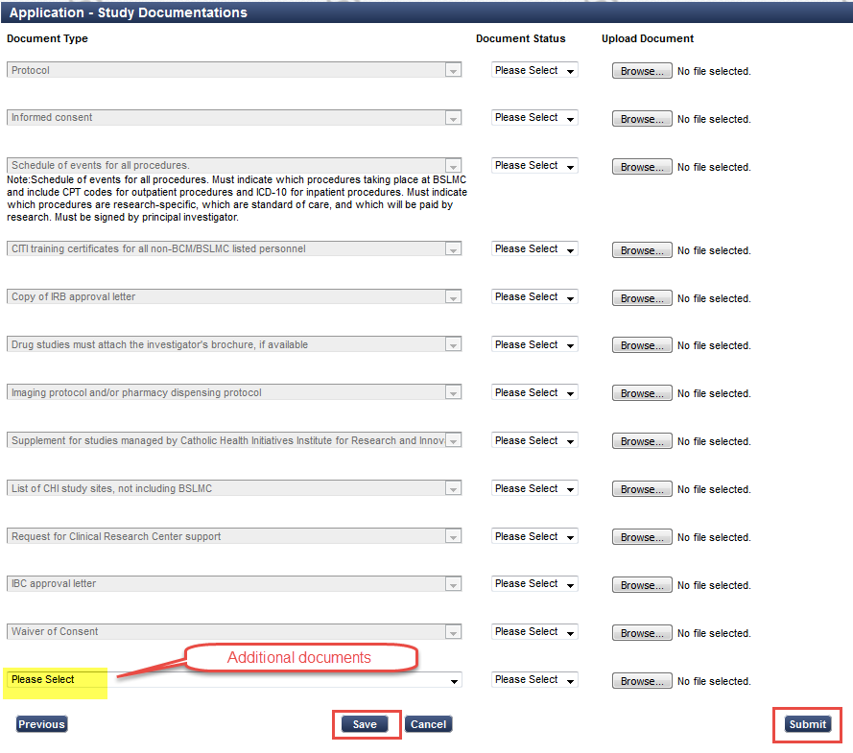

System generates email to PI to sign in and complete attestations.

# **PI Attestation, Acknowledgement and Submission**

PI will receive an auto-generated email when application is submitted by study team.

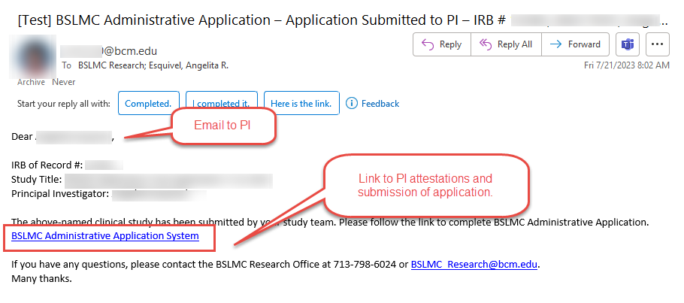

PI must check all attestations and acknowledgements to approve. A comment can be entered that will be viewed by the review team. PI will then either Submit the application for review or Reject the submission.

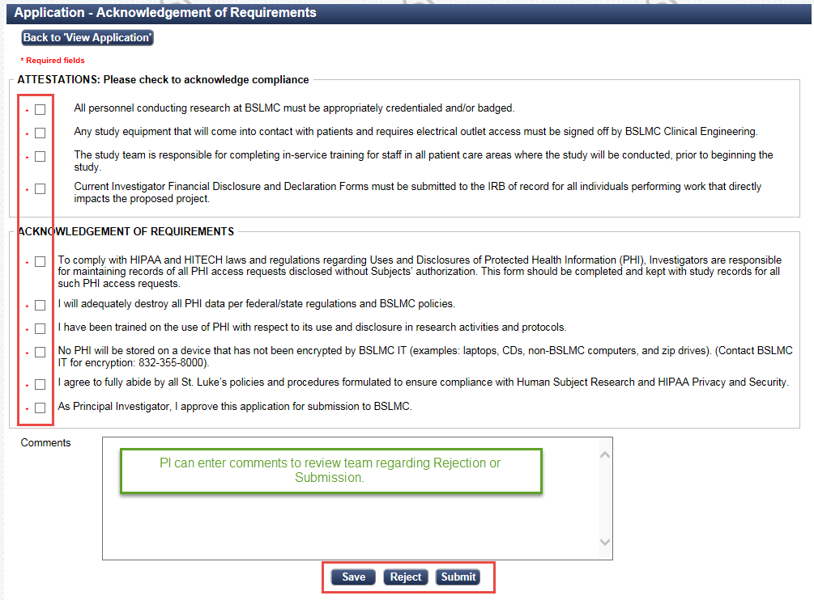

If the PI rejects the submission, the system will show this. The review team will not be able to see this study.

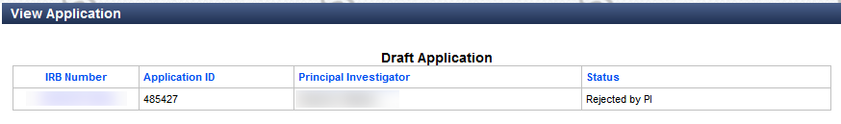

If the PI submits the application, an email will be generated letting the review team know that a new study has been submitted for review. You will be able to see submitted application and status in the Dashboard.

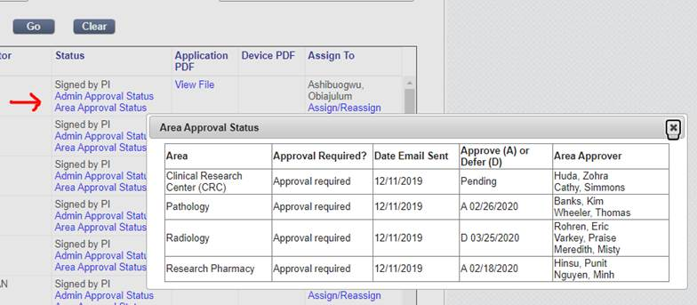

You may contact the Office of Clinical Research for any questions at [BSLMC_research@bcm.edu](mailto:BSLMC_research@bcm.edu) or 713-798-6024.

# **Institutional Approval or Deferral**

If the study is approved, an email with copy of signed letter and if applicable, financial agreement is sent to the PI and submitter informing them their study was approved.

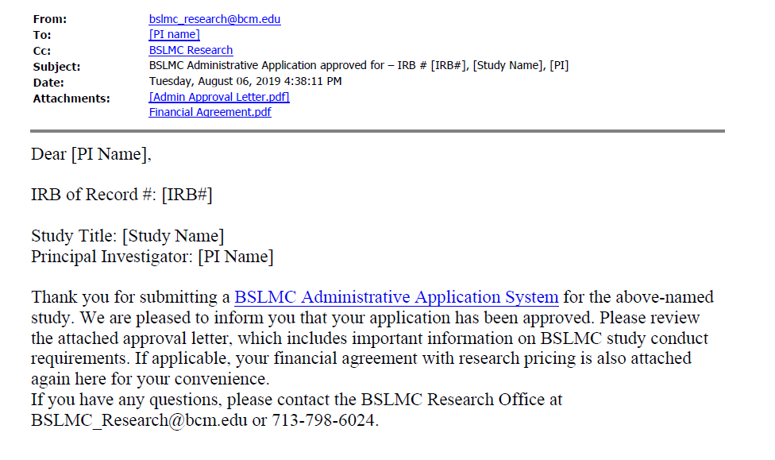

If study is deferred or not approved, then an email is sent to the PI and submitter informing them of the deferral.

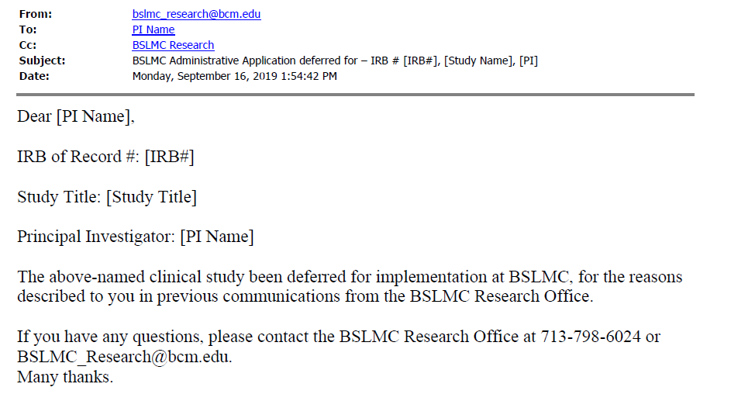

# **Institutional Acknowledgement for Expanded Access**

